

United Board Fellows Program

2027–2028 Instructions for Nomination

Please note that nominations must be submitted by the heads of institutions or senior administrators using an official email account. Please contact at ubfellows@unitedboard.org or bblwin@unitedboard.org if you have any questions about the nomination procedure.

- Go to the United Board’s application portal (https://unitedboard.smapply.io/prog/nomination_for_2027_-_2028_united_board_fellows_program/) and click “APPLY” in the “Nomination for 2027 – 2028 United Board Fellows Program” to start the nomination process (See the sample from last cohort).

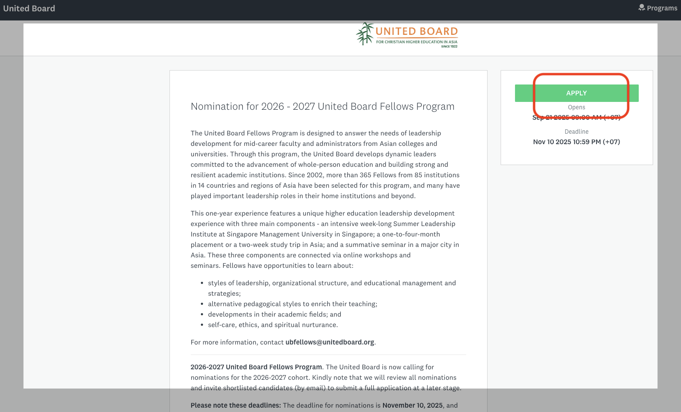

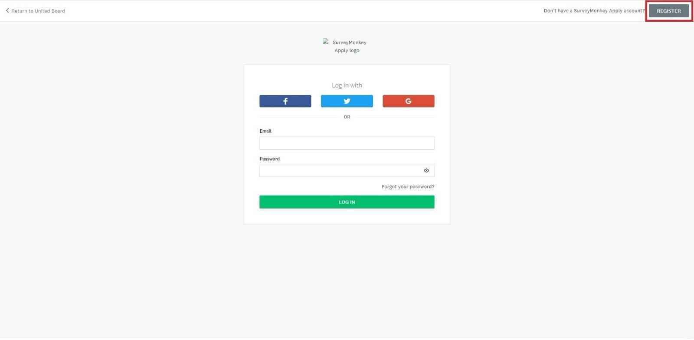
- Click “REGISTER” if you don’t have an account in the United Board’s application system (SurveyMonkey Apply). If you already have an account, please log in with your email and password. Please make sure to register or login with an official work email account, rather than a personal email account of the heads of institutions or senior administrators.

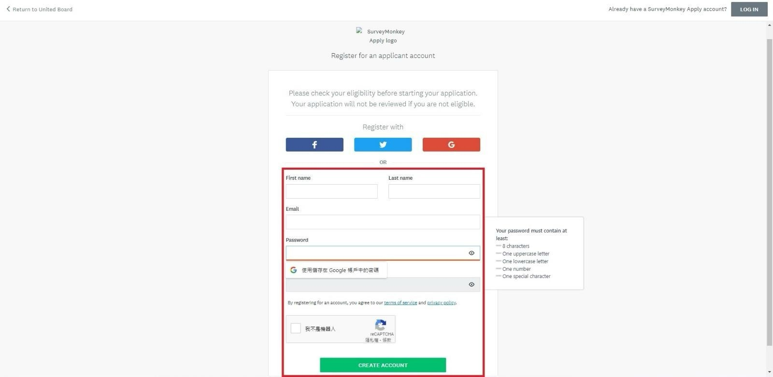
- Enter your “First name”, “Last name”, “Email” and “Password”, check “I am not a robot”, and click “CREATE ACCOUNT” to register if you don’t have an account in the United Board’s application system (SurveyMonkey Apply).

- Check your email inbox, ﬁnd an email named “SurveyMonkey Apply Account Email Veriﬁcation”, and click “Conﬁrm email address” to verify your email address as shown in the sample.
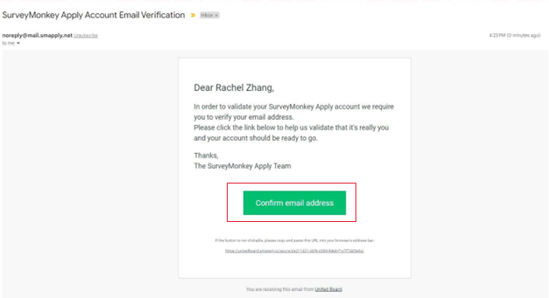

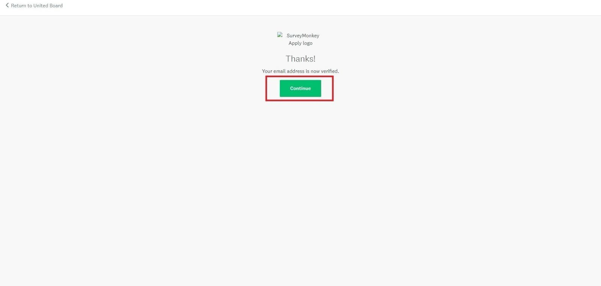
- Click “Continue” to return to the United Board’s application portal and continue your nomination.

- Type the Nominee’s name (E.g., “Bo Gyi” in this sample) and click “CREATE APPLICATION”.

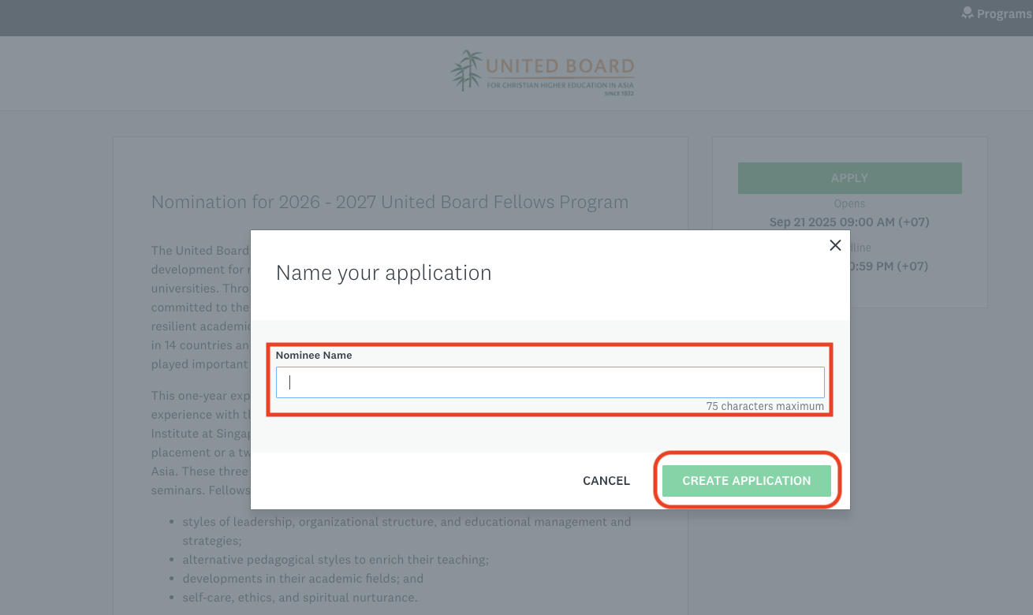

- Then, you will see this page. And click the Nomination to start filling out the nomination form.
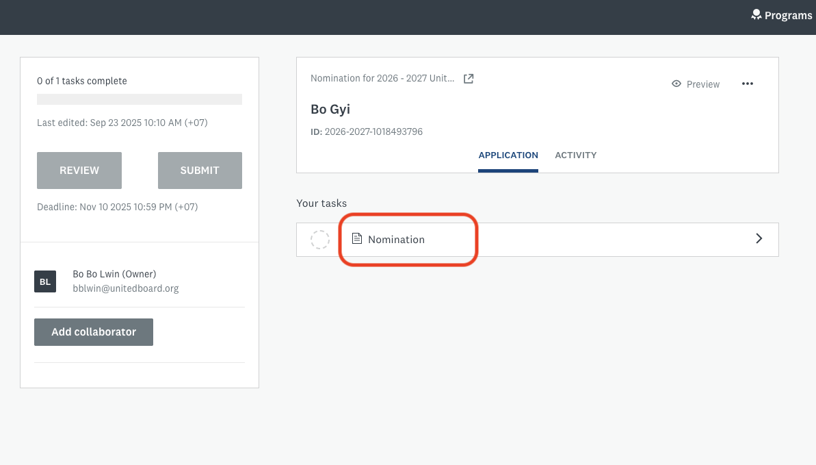

- Fill out the nomination form (See the sample of 2026-2027 Nomination Form).
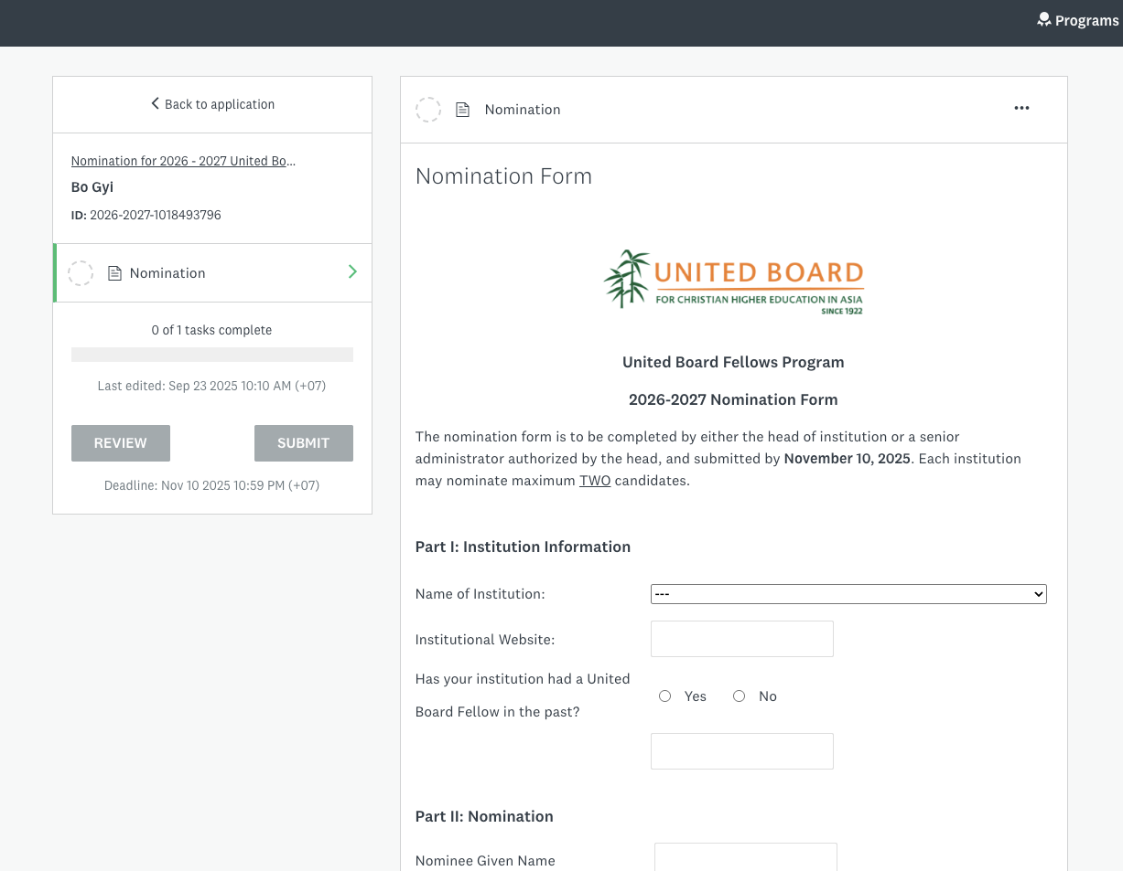

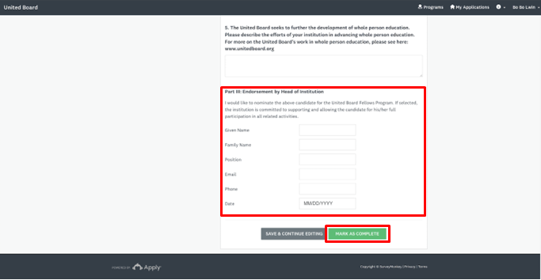
- Please provide your personal information at the end of the nomination form. Please be reminded to enter the email address you used for the registration. Once you complete the form, click “MARK AS COMPLETE”.

- Click “SUMBIT” to submit the nomination.

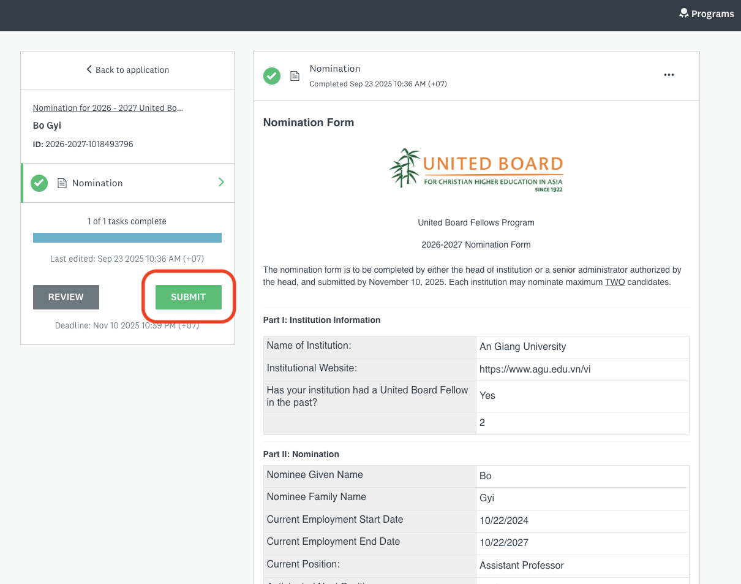

- Click SUBMIT to conﬁrm submission of your nomination.

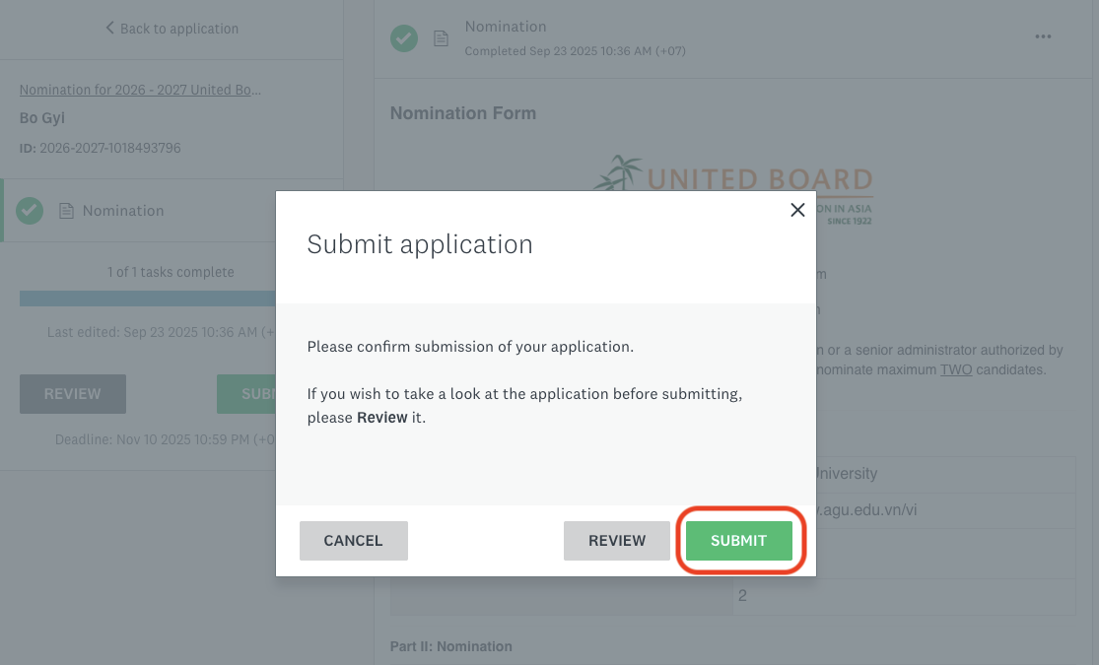

- Your nomination is submitted successfully. Click “View more Programs” to return to the application portal.
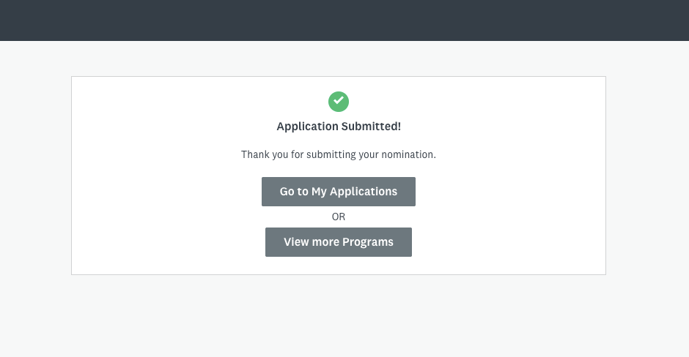

- Click “MORE” in the “Nomination for 2027 – 2028 United Board Fellows Program” to make your second nomination (See the sample of 2026-2027 nomination in the red box).
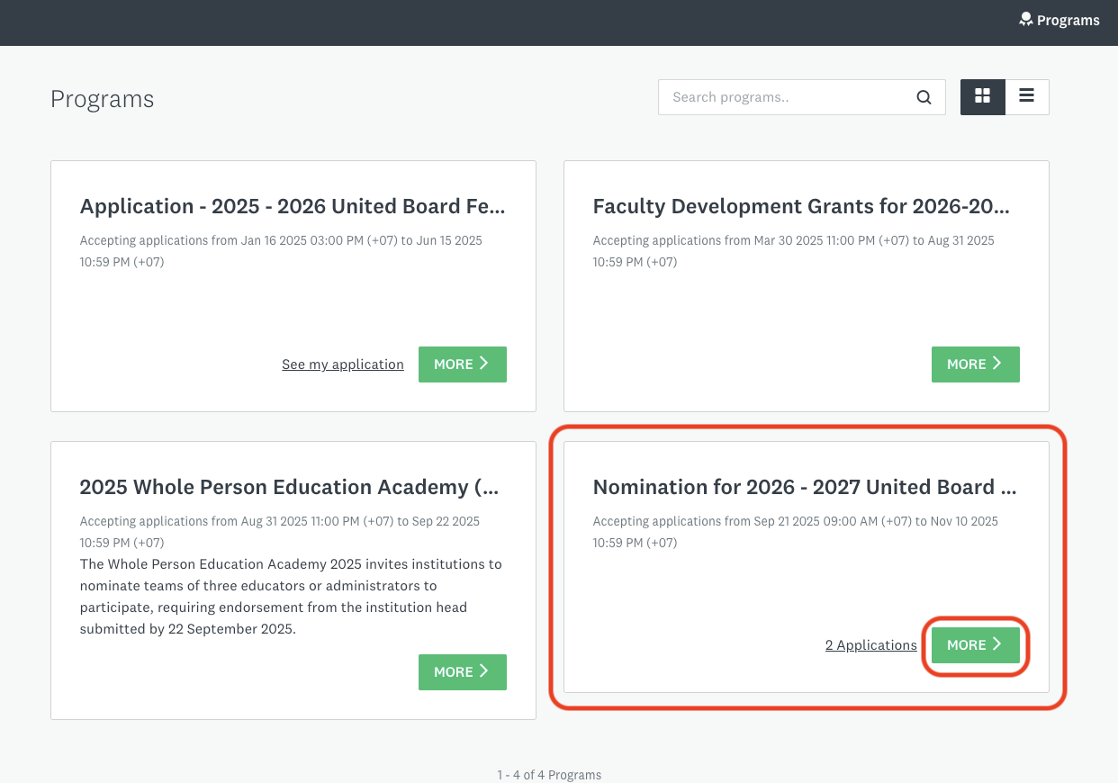

- Click “APPLY” to start the process of your second nomination.
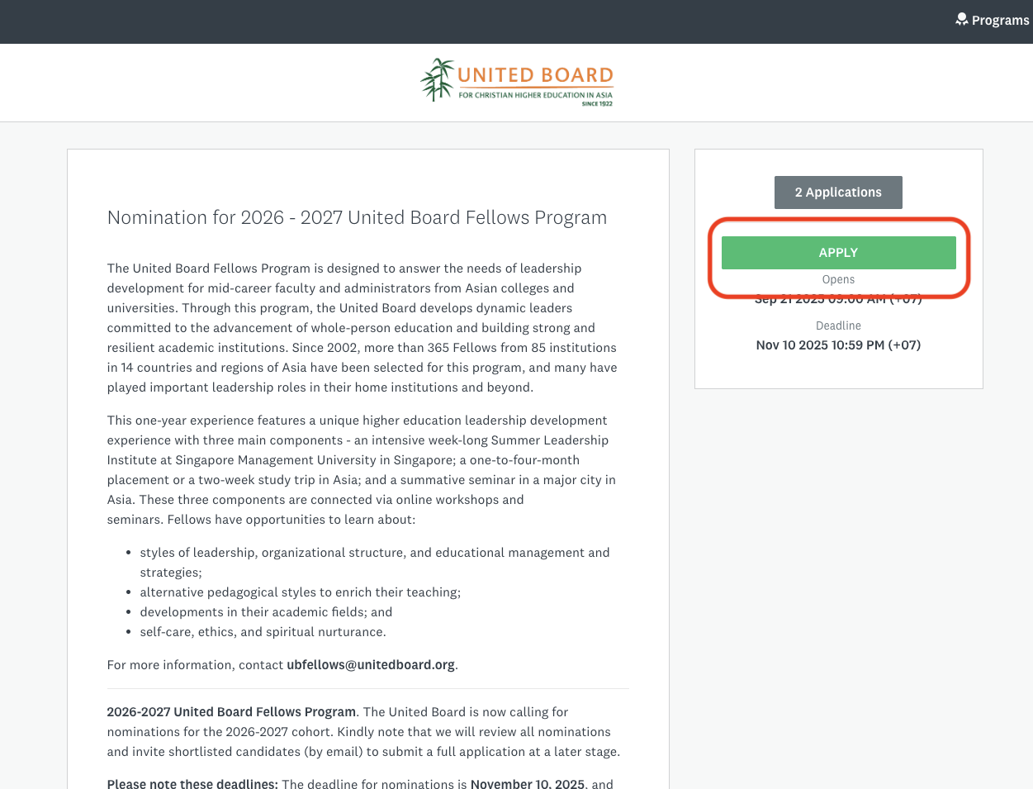

- Enter your second nominee’s name as the name of your second nomination and click “CREATE APPLICATION”. Repeat Step 7 to Step 11 to submit the second nomination.

- You will receive a conﬁrmation email once your nomination is submitted successfully.
